Arraylist in java collection: -
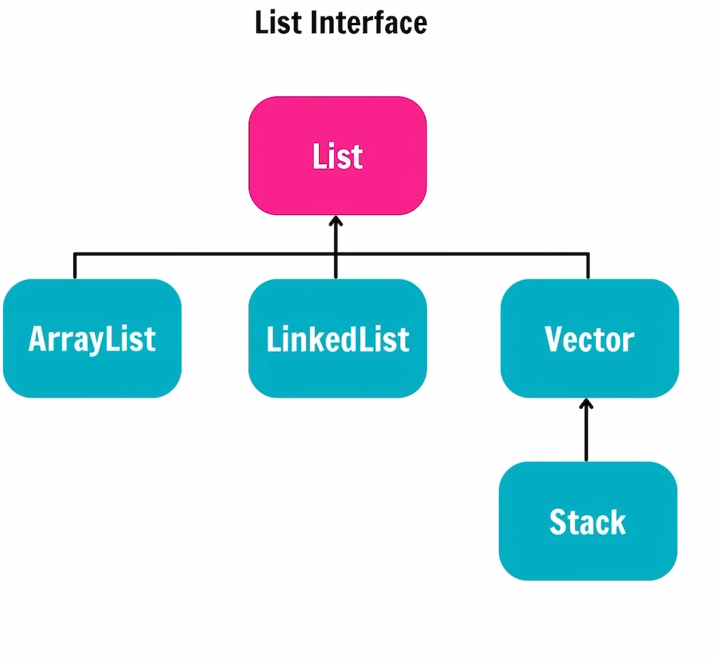

Array Data Structure properties: -
- Continuous memory allocation
- Fixed Size.
- Can store the Primitive Data Types
- We can Store object

ArrayList:-
- Non Continuous memory.
- It’s size is variable
- We can store only objects over here
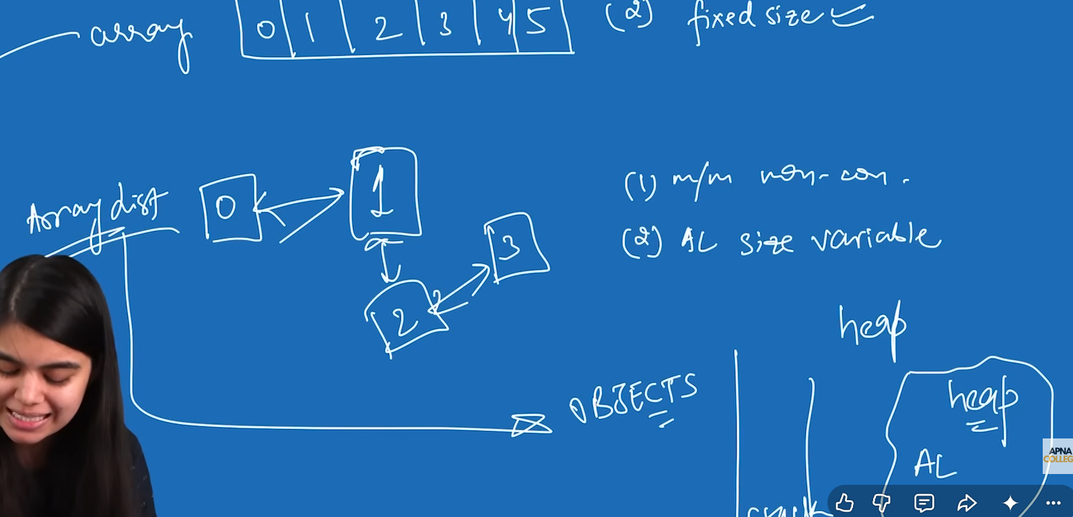

The Basic Operation that we are going to perform using arrayList:-


